DFAT Child Protection Guidance Note Establishing Child Protection Risk Context

  - September 2017

DFAT Child Protection Guidance Note

Establishing Child Protection Risk

Purpose
This guide will assist DFAT staff and partners or recipients undertaking activities or projects funded by DFAT in establishing the child protection risk context to help determine whether an assessment of child protection risk at the activity or project level is required. This guidance supports the DFAT Child Protection Policy 2017 (CPP) and is consistent with the DFAT approach to risk management.

Background
Establishing the context of risk is the first step in the risk management process and is circled in the diagram below.

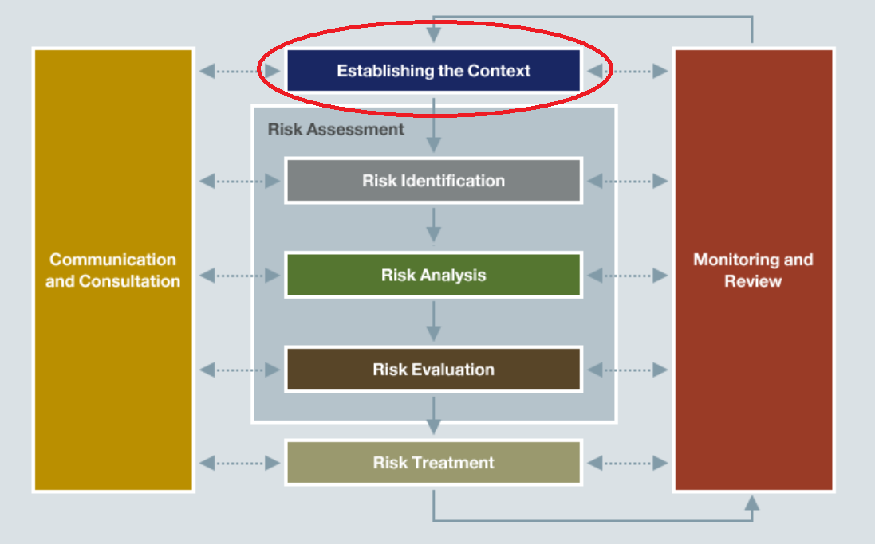

DFAT staff must ensure child protection risk is considered, and is managed in accordance with DFAT’s risk management practices. Child protection risks need to be assessed as part of standard risk management processes at design, implementation, monitoring and evaluation – and managed throughout the lifecycle of an activity or project.

There are common child protection risk context areas that DFAT staff and DFAT funded recipients or organisations can review to determine the likely risk level of the organisation and the level of contact between staff and children that will take place under the project or activity.
Risk levels included in this document are modelled on the DFAT Risk Matrix and follow the principles of the International Standard on Risk Management (AS/NZ 31000:2009).
‘High’ Risk Activities
Activities can be ‘high’ risk for a number of reasons. This can be due their nature, the organisation involved or a combination of both. Even though DFAT may be engaging in a low risk activity with an organisation, if that organisation is deemed a ‘high’ risk, then a child protection risk assessment must be conducted before engagement and risk monitoring conducted throughout the engagement.

Establishing the child protection risk context
There are three steps outlined in this guide that are used to establish the child protection risk context. Once you have completed the three steps you can establish the overall potential child protection risk context and determine whether a full child protection risk assessment is required.

Establishing Child Protection Risk Context
Step 1 | Does the activity involve working with children or contact with children?  This step will guide you through identifying the level of involvement with children.  If the activity is determined to be ‘working with children’ then a full child protection risk assessment is required
Step 2 | Is the organisation child-focused and what child protection controls are currently in place?
Step 3 | Based on the outcomes of the first two steps, determine the Child Protection Risk Context
Note: All steps must be undertaken. It is not enough to identify an activity as low risk.

Step 1: Does the activity involve working with children or contact with children?

There are two parts to this step:
Part A – Determine the activity level of working with or contact with children
Part B – Activity Inherent Risk
Use the definitions at the end of the document to assist with answering Part A and B

Step 1: Part A – What is the level of working with or contact with children at the activity level?
Complete the worksheet by adding a Yes or No response.
- Contact with Children - Assessment (No = nil contact)
Inherent risk | Personnel will be deployed internationally (outside their usual country of residence)?
 | Personnel will be working in a remote and/or rural location?
Degree of Isolation | Involves being alone with children?  (not frequently enough to be working with children)
 | Involves activities that are away from organisation location
Involves meeting one-on-one with children?
(not frequently enough to be working with children)
 | Involves unpredictable or remote settings?
Online contact or access to personal details | Involves direct one-on-one or group access to children online?
 | Involves supervising child-to-child online contact?
 | Involves online access to a child’s or children’s personal and/or confidential information?
 | Inadequate/missing safe options for children to report unwanted attention or inappropriate behaviour by others?
 | Involves educating children and supporting adults on cyber safety?
- Working with Children - Assessment
Vulnerability of child/children | Engages with children whose true or cognitive age impacts on their ability to protect themselves?
 | Engages with children who have challenges that contribute to their vulnerability? (e.g. psychological, situational)
 | Engages with children who do not have many support systems?

Degree of physical contact | Involves demonstrating a skill to children?
 | Position involves need for physical contact/touching children?
 | Involves providing a personal service? (e.g. washing, dressing, toileting)
Degree of monopoly | Monopoly on provision of goods and/or services  - Medical?  - Food distribution?  - Career training (sports/musical)?
Degree of supervision | Involves personnel having unsupervised contact with children?
 | Activities/engagement with children is not observed or monitored?
 | Insufficient number of trained staff to supervise activities/engagement with children?
Degree of trust | Involves developing close, personal, long term relationships with children?
 | Involves transporting youth?
Involves one or more of the following:
One-on-one supervision, overnight supervision, out of town activities, advising or offering guidance to youth or spending extended periods of time with youth e.g. camps?
 | Contributes to important decisions regarding the future of children?
Access to Property | Has access to personal/confidential information?
 | Adult has a perceived or actual level of authority? (from child perspective)
Skills and knowledge required | Requires specific skills, knowledge, qualifications or service eligibility requirements to undertake a child related position?
Child labour | Possibility that activity will lead to the employment of children?
 | Possibility that activity will lead to the removal of children from school?
 | Possibility that activity will lead to children being employed in hazardous work?
Vulnerability of parent/carer | Engages with parents whose true or cognitive age impacts on their ability to protect their children?
 | Engages with parents who have challenges that contribute to their ability to provide care? (e.g. psychological, situational)
 | Engages with parents who do not have many support systems?
Vulnerability can include: | Physical and mental disabilities, homelessness, child sex workers or parents who are sex workers, children and families impacted by disasters, displaced, migrants, refugees and asylum seekers, children in contact with the law, children that have been subject to trafficking, orphans, unaccompanied minors and the very young?

Step 1: Part B – Activity Inherent Risk
Based on your responses in Part 1, identify the inherent risk of the activity using the table below. Activity Risk is the level of potential risks to children due to the nature of the activity (working with children) or the design of the activity (design of the activity introduces risks to children).
LOW | No contact |  | The activity does not involve any individuals working in-country (Nil Contact) (you answered No to all questions in Step 1 Part A)
MODERATE | Contact with Children |  | The activity involves or may involve contact with children (working in-country, remote or rural area) (you answered Yes to any questions in ‘Contact with Children - Assessment’ but ‘No’ for all questions in ‘Working with Children - Assessment’)
HIGH | Working with Children |  | The activity involves working with children (you answered YES to any questions under ‘Working with Children - Assessment’)

Note: If an activity is determined to be ‘working with children’ then a full child protection risk assessment is required regardless of the organisational context outcome.

Step 2: Is the organisation child-focused and what child protection controls are in place?
There are two parts to this step:
Part A – Assessment of Organisation’s Focus on Children and strength of child protection systems in place
Part B – Organisation Inherent Risk

Step 2: Part A – Assessment of Organisation’s Focus on Children and Strength of Systems
Complete the worksheets below and add a Yes/No response against each question under ‘Systems and Controls’ and ‘Focus’.
Systems and Controls - Strength of systems and controls scaled by number of ‘yes’ responses.
Use the scale 0 Yes answers = poor systems, 9 Yes answers = strong systems
Child protection policy and procedures | Child Protection Policy in place?
 | Risk management practices in place and include risks to children
 | Recruitment practices, screening completed for all staff, before commencing work?
 | Notifications/Incident reporting procedures in place?
 | Staff receive child protection training?
 | Boundaries for appropriate behaviour/code of conduct are implemented?
 | Feedback on staff performance recorded?
 | Record keeping procedures are in place (meetings, activities, incidents, reports, logs, record of complaints)?
 | Organisation checks if third party service providers are child safe?

Focus - A child-focused organisation is an organisation that answers ‘yes’ to any of the questions below.
Types of activities | Does the organisation across all of its operations provide any direct activities/services for children?
 | Does the organisation provide any humanitarian relief?
Business model/services provided by organisation | Organisation provides Residential/Orphanage/Shelter services?
 | Organisation uses a child sponsorship model?
 | Organisation allows sponsors to visit with children?
 | Organisation is part of a ‘voluntourism’ program?
 | Organisation requires technical experience/expertise to implement child related services?
 | Organisation uses children and/or images of children as a ‘product’ for fundraising activities?

Step 2: Part B – Organisation Inherent Risk
Organisational risk is the level of potential risk posed by the organisation due to their ability to address child protection risks through their policies, procedures and systems and the type of work the organisation engages in (e.g. if they are a child focussed organisation, their risks will be higher).
LOW | NO FOCUS |  | Organisation is not a child-focused organisation ( you answered No to all questions in Step 2 – Focus)
MODERATE | FOCUS & STRONG SYSTEMS |  | Organisation is a child-focused organisation and has good child protection systems in place (You answered Yes to any question in Step 2 Focus and had a majority of Yes answers to the questions under systems and controls)
HIGH | FOCUS & POOR SYSTEMS |  | Organisation is a child-focused organisation and has poor or nil child protection systems in place (You answered Yes to any question in Step 2 Focus and had a majority of No answers to the questions under systems and controls)

Step 3: Establish the overall potential child protection risk context and whether a full child protection risk assessment is required
Once you have completed steps 1 and 2 you can establish the overall risk context by placing the results of each activity in the appropriate field below:
Organisation level of contact with children and systems in place  (organisation inherent risk from Step 2) | Activity Level of Contact with Children (activity inherent risk from Step 1)
 | NIL  (LOW) | CONTACT  (MODERATE) | WORKING  (HIGH/VERY HIGH)
NO FOCUS  (LOW) | No further assessment required | Include risks in relevant Investment risk register, monitor for changes | Full child protection risk assessment required
FOCUS & STRONG SYSTEMS  (MODERATE) | Include risks in relevant Investment risk register, monitor for changes | Include risks in relevant Investment risk register, monitor for changes | Full child protection risk assessment required
FOCUS & POOR SYSTEMS  (HIGH/VERY HIGH) | Full child protection risk assessment required | Full child protection risk assessment required | Full child protection risk assessment required

Low Risk | Moderate Risk | High Risk | Very High Risk
If the matrix indicates a full child protection risk assessment is required
Implementing Partners:
- Conduct a full assessment of the child protection risks within the organisation and activity using the organisation’s own risk management processes and documentation. A full child protection risk assessment requires the partner to assess all possible child protection risks within the activity.
- Show evidence to DFAT that the assessment has been completed and documented.
DFAT Staff:
- Conduct a full assessment of the child protection risks at design, tender, contract negotiation, implementation, monitoring and evaluation for the lifecycle of the activity, in accordance with the Aid Programming Guide and the Risk Management for Aid Investments Better Practice Guide.

If the matrix indicates a requirement for monitoring of child protection risks, it is recommended that the risk be included in the relevant Investment risk register and monitored accordingly.
Identify and record who completed the steps above and when full child protection risk assessment (if required) will be completed.

Definitions
Working  With  children | Working with children means being engaged in an activity with a child where the contact would reasonably be expected as a normal part of the activity and the contact is not incidental to the activity. Working includes volunteering or other unpaid work.  The risks of child exploitation and abuse generally increase with the frequency of contact, meaning that working with children is a higher risk than contact with children.
Examples | Activities or services for children:  - Disability service  - Cultural youth exchange  - Residential care  - Child protection services  - Justice facilities for children  - Childcare services  - Child education services, Children in sports  - Child accommodation services  - Health services, Access to Sexual & Reproductive Health  - Counselling and support services for children  - Emergency response, Humanitarian assistance to children and families
Contact  With  children | Contact with children means being engaged in an activity or in a position that involves or may involve contact with children, either under the position description or due to the nature of the work environment. This means physical contact, face-to-face contact, oral communication, written communication or electronic communication.  Contact covers contact with children in the community not associated with the work being performed.
Examples | - Any international work, in particular working in remote/rural locations  - Oral and written communication (including electronic communication) relating to a child  - Visiting premises e.g. schools, health or residential facilities, that provide services to children  - Any community consultation (data collection, surveying, training)  - Women and Gender focussed activities  - Health Sector Programs

The Risk Management Process - International Standard on Risk Management (ISO 31000:2009)
Child protection controls for example can be, organisations undertaking child safe recruitment practices or ensuring their staff sign a child protection code of conduct. Controls are applied to limit the likelihood of a risk taking place.
A no response to all or most questions would indicate a high-risk organisation due to poor systems. A yes response to all or most questions would indicate strong systems
A yes would indicate that an organisation would require a higher degree of child safeguarding than the minimum detailed in the DFAT Child Protection Policy.
Voluntourism is “Volunteer travel, volunteer vacations or voluntourism is travel which includes volunteering for a charitable cause” Voluntourism is a business model that has been shown to be very high risk to children.
See DFAT’s Child Protection Guidance Notes for guidance on risks and mitigation measures within certain sectors http://dfat.gov.au/about-us/publications/Pages/child-protection-policy.aspx or contact the Child Protection Compliance Section on child.protection@dfat.gov.au.

