ACFID National Conference 2022 Concurrent Session Information Pack

Instructions
- Read all sections of this Information Pack to learn about what we’re looking for and what’s involved. Contact rlans@acfid.asn.au to request a briefing and/or more information.
- Send this opportunity to your local partners (sessions will be reserved for EOIs led by partner organisations).
- Complete all sections of the Application Form and send to rlans@acfid.asn.au by 5pm AEST Tuesday 19 July 2022.

What is this year’s theme?
The theme of the ACFID National Conference 2022 is Healthy Planet, Healthy Communities: Acting with Evidence, Equity, and Inclusion for a Resilient Future.
Climate change and the state of our ecological systems is the defining challenge of our time. Estimated to push 100 million people into poverty by 2030, climate change will disrupt and reverse economic and human development, exacerbate natural disasters and humanitarian emergencies and destabilise security across our region. Over-exploitation of ecosystems will constrain already vulnerable communities to adapt to climate change and have a greater impact on the poorest and most marginalised people around the world, in particular women and girls, threatening food security, access to clean water, health and the homes and livelihoods of hundreds of millions of people around the globe.
These impacts come on top of the ongoing health and economic disruptions caused by COVID-19, which has the potential to affect the Pacific to a greater extent in 2022 than during previous stages of the pandemic.
These interconnected issues require deep listening, indigenous knowledge and a combination of local solutions and global action if we are to be effective in our actions. As the social and economic fallout of COVID-19 builds, the effects of a changing climate and restoring ecosystems around the world must remain at the forefront of global response efforts. This will be explored through current examples from within and external to the sector, centring on the cross-cutting principles of:
- Evidence: actions, programs and solutions informed by evidence.
- Equity: action that promotes and upholds the rights of groups affected most and seeks to address inequalities.
- Inclusion: the inclusion of local and marginalised groups to inform and design action.

What are our selection criteria for concurrent sessions?
We are looking for concurrent sessions that:
- Share local solutions and hear directly from local partners.
- Engage delegates in creative ways, particularly concise formats such as single case studies, one-one-one interviews / fireside chats, lightening talks and data blitzes.
- Demonstrate how organisations are integrating climate action into operations, programs, or policy and advocacy, particularly sessions aligned with one of the nine action areas of the ACFID Climate Action Framework.
- Contribute to advancing the theme ‘Healthy Planet, Healthy Communities: Acting with Evidence, Equity and Inclusion for a Resilient Future’.
- Share practical insights, actionable strategies and/or reflections and learnings.
Top Tips for Success!
A large proportion of concurrent session allocations in the 2022 program will be for 30-minute sessions that align with one of the nine action areas of the ACFID Climate Action Framework.
When completing the application form, ensure that you address all the selection criteria.
Concurrent session allocations will be reserved for EOIs led by partner organisations. ACFID members are encouraged to share this opportunity with their local partners.

What is a ‘virtual’ concurrent session?
This year all concurrent sessions will be virtual sessions. Our online conference platform will bring together speakers and delegates, and there will be no in-person elements. We encourage you to consider approaches suited to delivering an engaging online session. For questions and ideas about designing engaging online sessions, contact rlans@acfid.asn.au

General guidelines for concurrent sessions

Session Design
Your EOI needs to specify your session format and approach to interacting with delegates. Format options include:
- Single case study presentation
- Multiple case study panel
- Interview/fireside chat
- Lightening talk
- Data blitz
- Poster presentation
- Discussion/roundtable
- Workshop
Each of these formats can be matched with different ways to interact with delegates, including audience Q&A, polling/surveys/pulse checks, small group activities/discussion in breakout rooms, sharing files and links, etc.

Time Allocations
Virtual concurrent sessions can run for 30, 60 or 90 minutes.
Most concurrent session allocations in the 2022 program will be for 30-minute sessions that align with one of the nine action areas of the ACFID Climate Action Framework. 30-minute sessions are suited to single case study presentations, one-one-one interviews / fireside chats, lightening talks, data blitzes, poster presentations, etc.

A smaller number of longer concurrent sessions will also be included in the program, such as 60-minute sessions (which are suited to many formats but should not feature more than three speakers) and 90-minute sessions (which are suited to more interactive sessions such as roundtables and workshops). To help keep sessions to time, we recommend incorporating pre-recorded speaker components into your session design.

Session Speakers
Speakers can be involved in your session as a live speaker or via a pre-recorded video. Pre-recorded video can be used to accommodate speakers’ time zones, low internet connectivity, etc. Pre-recorded video can also be used to streamline the speaker segments of your session.

Virtual sessions successfully support fewer speakers compared to in-person sessions. Unless you arrange pre-recorded speaker videos, we recommend limiting the number of speakers in your session to no more than four speakers, including for 90-minute sessions.

Session Preparation
If your session is selected, you will work with ACFID to prepare your concurrent session. You will correspond and/or meet regularly with organisers from ACFID to:
- Share the purpose, objectives, and outcomes of your session.
- Refine the format and delegate interactions of your session.
- Confirm the participation and roles of your speakers/presenters.
- Brief your speakers to prepare them for being part of your session.
- Access support in preparing and promoting your session.

Support from ACFID
If your session is selected, ACFID provides:
- A contact point for ensuring alignment with ACFID’s requirements, for organising session logistics and support in achieving delivery of stated session objectives and outcomes.
- Platform, audio-visual, and other event support as required and agreed.
- Promotion via the conference program, website, app, and ACFID social media channels.
- Waiving of conference registration fees for your session speakers/presenters.

Key Dates
Week of 2 May: Call for Applications
5pm AEST Tuesday 19 July: Due date for all applications
- Monday 25 July: Notification of acceptance
- Monday 29 August: Deadline to confirm session title and description
- Monday 26 September: Deadline to confirm session speakers
- Monday 17 October: Deadline to finalise all session logistics and details
Wednesday 26 and Thursday 27 October: ACFID National Conference 2022

Submission Process
To submit your EOI:
- Read the EOI information pack and contact rlans@acfid.asn.au with any enquires.
- Complete the EOI form, ensuring all sections are answered.
- Send the EOI form to Jess Smith via rlans@acfid.asn.au by 5pm AEST 19 July 2021.

ACFID Contact
For questions or more information contact Jess Smith via rlans@acfid.asn.au

Attachment: ACFID Climate Action Framework
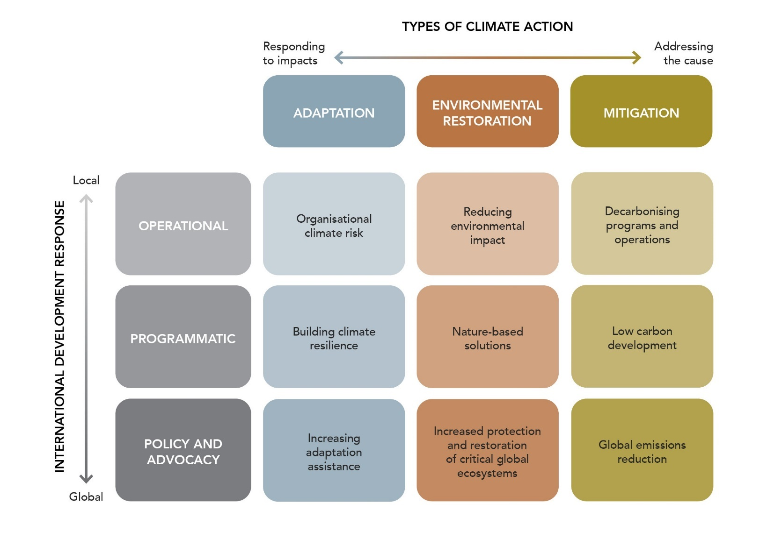
Figure 1: The ACFID Climate Action Framework links the 3 main types of climate action (adaptation, environmental restoration, and mitigation) to 3 different levels of response (operational, programmatic, and policy and advocacy). This provides a matrix of 9 action areas.
The 9 action areas of the ACFID Climate Action Framework are:
- Organisational climate risk (operational level adaptation responses)
- Reducing environmental impact (operational level environmental restoration responses)
- Decarbonising programs and operations (operational level mitigation responses)
- Building climate resilience (programmatic level adaptation responses)
- Nature-based solutions (programmatic level environmental restoration responses)
- Low carbon development (programmatic level mitigation responses)
- Increasing adaptation assistance (policy and advocacy level adaptation responses)
- Increased protection and restoration of critical global ecosystems (policy and advocacy level environmental restoration responses)
- Global emissions reduction (policy and advocacy level mitigation responses)

