ACFID Development Practice Committee (DPC)
Terms of Reference

The DPC is one of several expert reference groups established by ACFID to support the realisation of ACFID’s vision and the delivery of the ACFID strategic plan.

The ACFID Development Practice Committee’s (DPC) objective is to enhance the development sector’s relevance, effectiveness, efficiency and sustainability.

The DPC will work to achieve this objective through:

- Championing good practice within the ACFID membership and with other development actors.
- Leading or supporting specific initiatives which align with ACFID’s strategic priorities, address sector needs and extend understanding of development practice.
- Providing strategic and operational advice to ACFID Secretariat, to ACFID Board and to other ACFID working groups and committees as requested.
- Engaging with DFAT on development effectiveness policy and practice.

Any changes to the ToR must first be endorsed by the DPC and approved by the CEO.

Links to ACFID Strategic Plan 2020 -2025

The work of the DPC aligns with the strategic goals and thematic focus areas in the ACFID Strategic Plan 2020-2025, found here : :

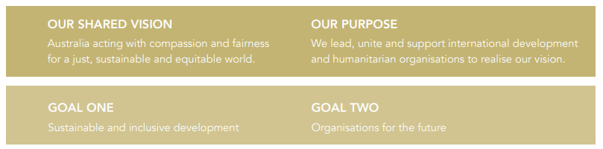
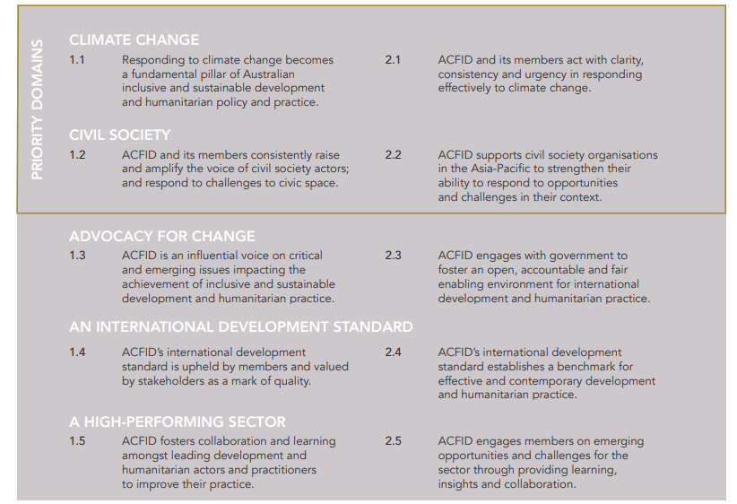

Membership

The membership of the DPC will primarily be made up of participants from member agencies but may also include external experts such as academics, consultants or subject matter experts from think tanks. The committee will ensure it has the following skills and experience amongst its members:

- Experience in program design, implementation and monitoring and evaluation across a range of countries and sectors, including in the field
- Experience in developing and socialising program management frameworks, guidelines and tools
- Experience in dealing with DFAT requirements
- Experience in one or more of applied research, capacity building, organisational development, policy dialogue, and development practice
- Experience in and knowledge of ACFID’s thematic focus areas
- Understanding and knowledge of the not-for-profit development sector
- Links to institutions or inter/national networks that support the work of the DPC in meeting the objectives of the ACFID Strategic Plan.

Consideration should be given to ensuring DPC membership has:
- Gender balance
- Balance between small, medium and large member agencies
- Balance between faith and non-faith-based agencies
- Racial and ethnic diversity
- A majority (80%) of ACFID member participants, and
- Purposefully incorporated a diversity of perspectives, personal attributes and lived experiences.

DPC members should be able to commit at least 12 days per year to DPC activities, including attending face to face meetings (moving between Sydney, Canberra and Melbourne and online), participating in work between meetings, contributing to fora and leading or supporting specific pieces of work.

Membership on the DPC is for a three-year term. All members are eligible for renomination.

Full membership of the DPC should not exceed more than 12 members with at least eight from ACFID member agencies. The number of members should be reviewed at 12 months from the date of this Terms of Reference.

Vacancies

When a vacancy arises on the DPC, the ACFID Secretariat coordinates a call for expressions through the ACFID Member Bulletin, the ACFID website and the Research for Development Impact Newsletter. In response to nominations received, the DPC will appoint a new member based on the selection criteria outlined above with a formal recommendation to the Chief Executive Officer to confirm appointments.
If insufficient nominations are received, nominations shall be reopened across all member agencies.

All resignations by DPC members must be formally noted by the DPC and the Chief Executive Officer.

Co-chairs
The two co-chairs are elected by DPC members for a staggered renewable three-year term. The role of the Chairs is to:
- Provide leadership to the committee
- Lead the development and delivery of the committee’s work plan
- Set the agenda for and facilitate meetings of the committee
- Represent the committee to internal and external stakeholders
- Ensure the committee’s accountability requirements are met.

Advisors

The category of advisors has been created to allow the DPC to appoint experts in a particular field who are unable to fully contribute to the DPC to still be involved in the group on an ad hoc basis. The DPC may appoint advisors for a three-year term or for the duration of a particular project.

ACFID Secretariat Role

The ACFID secretariat will:
- Provide input to the DPC work plan.
- Lead or support the delivery of DPC-prioritised initiatives which are aligned with the ACFID operational/strategic plans, including through the allocation of staff time and budget. The Director of EET holds a budget allocation for DPC activities as needed.
- Support the preparation for, delivery of and follow up to DPC meetings
- Facilitate liaison between DPC and other actors, particularly DFAT
- Facilitate provision of an annual report to the Board – in line with ACFID’s Performance and Learning Framework

Operations

Ordinary meetings of the DPC will be held three - four times a year rotating between Sydney, Melbourne, Canberra or virtual, depending on Committee membership. There will be a mix of one and two-day meetings. Virtual meetings will be held as needed throughout the year to progress pieces of work between committee meetings. Travel expenses associated with committee participation are covered by the agency.

The DPC will keep minutes of its meetings and provide a copy of the minutes to the Board or the CEO on request.

The DPC will develop a rolling, two-year work plan that is aligned with ACFID’s Strategic Plan and ACFID’s Operational Plan for consideration by the Chief Executive Officer in April of each year. The approved plan will be reviewed and updated every 12 months.

The DPC will report to the Chief Executive Officer against the work plan on an annual basis and on specific projects as and when requested. The CEO will be invited to attend DPC meetings.

The DPC will report to the Board via the CEO yearly, either in writing or joining the Board meeting as needed.

In order to select specific initiatives for the work plan, the DPC will use the following criteria:
- Degree of alignment with and contribution to the ACFID strategic and operational plans.
- Addresses gaps in the sector and/or mitigates risks to the sector and/or exploits emerging opportunities. Adds value to development actors, to ACFID members as whole or to a substantial sub-set of members.
- Will benefit from coordinated action at sector level.
- Capitalises on DPC’s achievements to date, experience and expertise and lends itself to DPC’s preferred approach to change – investigate, dialogue and enable.
- Capitalises on demonstrable agency interest, commitment and capacity.
- Builds on or complements existing work undertaken by members and/or by ACFID and/or by DPC and/or by other ACFID-related entities e.g., CCC, HRG, AUNC etc.
- Is feasible within existing resource/time constraints.

These criteria apply particularly to the pro-active work undertaken by DPC but can also be used – in whole or part – to assess reactive work.
Quorum
A simple majority will be considered the minimum number of DPC members required for decisions that require a vote. For all other decisions the aim is to achieve consensus.

